1.1)Write a C Program to implement Shift Cipher.

PROGRAM:

#include<stdio.h>

#include<string.h>

#include<conio.h>

#include<ctype.h>

int main()

{

char plain[10],cipher[10];

int key,i,length;

printf("Enter the plain text: ");

scanf("%s",plain);

printf("\nEnter the key value: ");

scanf("%d",&key);

printf("\n \n \t PALIN TEXT: %s",plain);

printf("\n \n \t ENCRYPTED TEXT: ");

for(i=0,length=strlen(plain);i<length;i++)

{

cipher[i]=plain[i]+key;

if(isupper(plain[i]) && (cipher[i]>'Z'))

cipher[i]=cipher[i]-26;

if(islower(plain[i]) && (cipher[i]>'z'))

cipher[i]=cipher[i]-26;

printf("%c",cipher[i]);

}

printf("\n \n \t AFTER DECRYPTION: ");

for(i=0;i<length;i++)

{

plain[i]=cipher[i]-key;

if(isupper(cipher[i])&&(plain[i]<'A'))

plain[i]=plain[i]+26;

if(islower(cipher[i])&&(plain[i]<'a'))

plain[i]=plain[i]+26;

printf("%c",plain[i]);

}

getch();

}

OUTPUT:

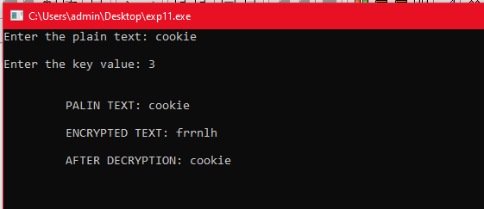

1.2)Write a C Program to implement Mono-Alphabetic Substitution Cipher.

PROGRAM:

#include<stdio.h>

char monocipher_encr(char);

char alpha[27][3]={ {'a','f'},{'b','a'},{'c','g'},{'d','u'},{'e','n'},{'f','i'},{'g','j'},{'h','k'},{'i','l'},{'j','m'},{'k','o'},{'l','p'},{'m','q'},{'n','r'},

{'o','s'},{'p','t'},{'q','v'},{'r','w'},{'s','x'},{'t','y'},{'u','z'},{'v','b'},{'w','c'},{'x','d'},{'y','e'},{'z','h'}

};

char str[20];

int main()

{

char str[20],str2[20];

int i;

printf("\n Enter String :");

gets(str);

for(i=0;str[i];i++)

{

str2[i]=monocipher_encr(str[i]);

}

str2[i]='\0';

printf("\n Before Decryption: %s",str);

printf("\n After Decryption: %s\n",str2);

}

char monocipher_encr(char a)

{

int i;

for(i=0;i<27;i++)

{

if(a==alpha[i][0])

break;

}

return alpha[i][1];

}

OUTPUT:

